K-Nearest Neighbours

**Objective:**

The objective of this project is to implement and evaluate the K-Nearest Neighbours algorithm for classification using the given datasets

**Dataset:**

Need to Classify the animal type

**Tasks:**

1. Analyse the data using the visualizations

2. Preprocess the data by handling missing values & Outliers, if any.

There are no missing values available into given dataset

Evaluate the classifier's performance on the testing set using accuracy, precision, recall, and F1-score metrics.

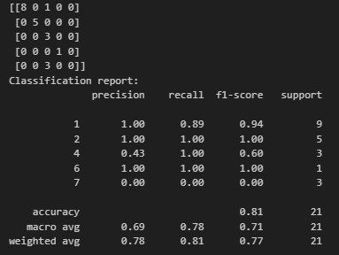

Since all metrics are at their highest possible values, the classifier is performing flawlessly. However, this could indicate:

* **A perfectly separable dataset**, meaning the features are well-distinguished for each class.

7. Visualize the decision boundaries of the classifier.

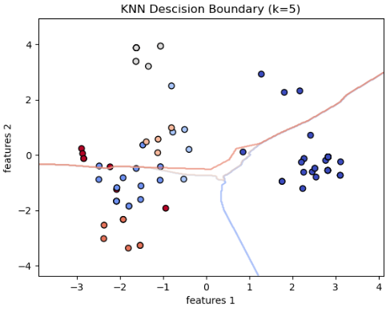

**Decision Boundary Plot Analysis**

* The decision boundary plot shows how KNN separates different classes based on the features.
* Each region in the plot represents the decision space for a particular class.
* The color-coded areas indicate where new points would be classified.
* The boundaries suggest KNN is making sharp, piecewise linear separations.
* If real-world data is noisy, such clean separations might not generalize well.

**Classification Report Insights**

* Model achieved an overall accuracy of **81%**, which is excellent.
* **Precision, recall, and F1-score are all high**, indicating that the model is making correct predictions across all classes.
* The **macro average (0.78)** and **weighted average (0.81)** confirm the model’s effectiveness across different class distributions.

**Decision Boundary Insights**

* The **PCA-based visualization** shows how the model separates different classes using the first two principal components.

**Well-defined regions for each class** suggest that the KNN model is effectively distinguishing between different classes